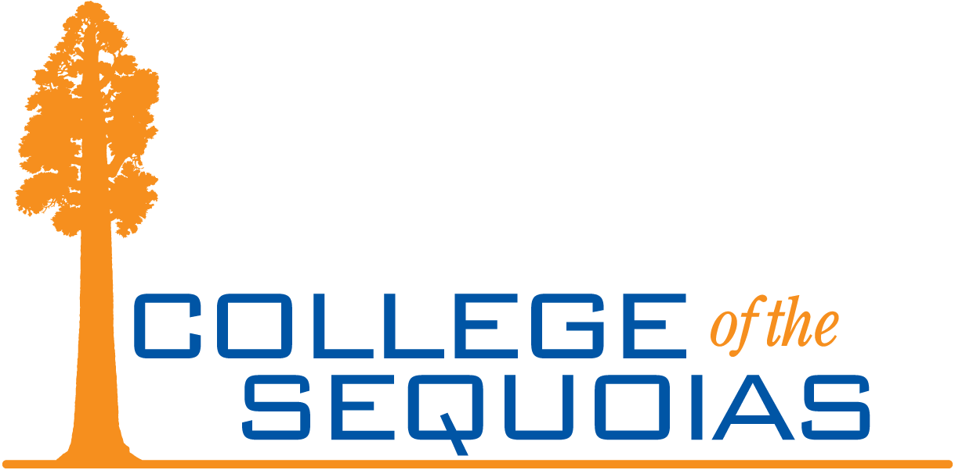**General Education Committee**

**Fall 2023**

**Present: Linda Flora, Sarah Harris, Travis Burkett, Josh Muller, Justin Aceves, Daniel Alvarado, Allison Ferry-Abee, Laura Harris, Jesse Wilcoxson**

**Absent:**

**Student Rep:**

**Guests: Justine Kincade, Tracy Redden**

**General Education Committee**

# Friday, August 25, 2023

# 12:00 pm – 1:30 pm, Online – Zoom

# Quorum: 6 voting members must be present

1. **Call to Order –** Meeting called to order at 12:03 pm.
2. **Comments/Questions:**
   1. **Regarding items on the agenda –** None.
   2. **Regarding items not on the agenda –** Sarah Harris introduced herself and shared her role with the GE Committee.
3. **Unfinished/Ongoing Business:** 
   1. **Meeting minutes for April 28, 2023 –** MSC Harris/Aceves. No discussion. 6 approved, 0 no, 0 abstention. Item approved.
   2. **FA 2024 Requirements for Associate Degree –** Sarah Harris shared feedback from the Curriculum Committee about incorporating Ethnic Studies into the COS GE. The Curriculum Committee was leaning towards option 3. Sarah asked for feedback.
4. **New Business** 
   1. **First meeting requirements** 
      1. **Review GW role within COS Governance Structure –** Linda Flora shared the Decision Making Manual and the GE Committee’s role.
      2. **Review GE Committee Bylaws –** Linda Flora shared the GE Committee Bylaws.
      3. **Evaluation Survey results –** Linda Flora shared the GE Committee survey results including comments. Members discussed.
   2. **Possible initiatives for 2023-2024**
      1. **Standard Business –** Linda Flora covered this item.
      2. **Governance Survey review –** Linda Flora covered this item.
      3. **GE Framework updates –** Linda Flora suggested this as a possible initiative.
      4. **GE Philosophy –** Linda Flora suggested this as a possible initiative.
      5. **Develop GELO Assessment in partnership with O and A Committee –** Linda Flora suggested this as a possible initiative. Sarah Harris shared that Outcomes and Assessment Committee drafted survey items associated to the new GELOs and ILOs to get feedback and make modifications.
   3. **Title 5 Regulation updates –** Sarah Harris shared updated language to Title 5 Regulations related to Associate Degree Requirements. Members discussed.
   4. **Draft COS GE Pattern –** Sarah Harris shared a draft updated COS GE pattern. Members discussed. Members were asked to get feedback from their departments/ divisions.
5. **Old Business**
6. **Adjournment –** Meeting adjourned at 1:05 pm. MSC Harris.